**SOFTWARE REQUIREMENTS ENGINEERING**

**PROJECT DOCUMENTATION**

PHARMACY INVENTORY MANAGEMENT SYSTEM

AROOSA GHAZAL 3151

MARYAM MUSADDIQ 3183

NIMRAH YOUSUF 3178

**SUBMITTED TO**: Ma’am Asma

|  |  |
| --- | --- |
| PROBLEM | DESCRIPTION |
| The Problem of | Maintaining manual record of medicines and availability of medicines |
| Affects | Patients, Doctor, Pharmacist/Storekeeper, Pharmaceutical Companies: Delivering batch of medicines to the store Weekly/Monthly, Government Health Ministry: Set standardized process for stores to follow |
| The result of which | Customer dissatisfaction, time consuming for storekeeper, hard to maintain and access the collection’s record, hard to maintain standards of quality set by government |
| Benefits of | **That creates a new system to address the problem include**  An automated system that keeps track of record  Backup of the system  Give results in a reasonable small time interval  The system shall accept, update, deletion and alteration of data. |

# **Problem Statement**

# **Fish Bone Analysis**

# **Introspection**

Use automated system for pharmacy inventory management system to remove all the problems that occur in manual work. Develop a database that shall provide easy storage retrieval and give results in a reasonable small time interval, easy to access inventory information and be able to make weekly/monthly inventory reports. Also develop a mobile based application for customers where they can view the availability of medicines as well as their prices.

In automated system you can use proper files, folders or software tools to organize your data about medicines. **Management** will be improved as tasks will be completed in a very less time and easily. **Process** will improved as every detail will be listed properly for example expiry date of medicine, remaining stock, finished stock etc. **Procedure** will be improved as by using automated system critical quantity of medicine will be reminded easily. Easy to do sales and supply analysis as the data is organized. **Stock** can be updated easily by the storekeeper and customers can easily know about the availability of medicines through app. Using automated system, **people** do not have to wait too long as the retrieval process is fast in automated system. Less staff can complete their tasks that will result in increased salary of employees and they can easily handle their work.

# **Brainstorming**

**Idea Generation**

**Author**: Maryam Musaddiq **Date**:

**Material:**

Too much paper work will be reduced as we use computer systems.

Documentation will be organized as we store all information in database in a proper systematic way using files and folders.

**Management:**

Too much or too little inventory is a problem, in your computer system keep record of fastest moving item.

When employees keep record using pen or paper a lot of time and effort is consumed so use computer system for this purpose and update record easily.

Because of excessive effort is needed staff has no interest in work so by replacing pen and paper with automated system, staff will work with satisfaction.

For every manual activity you need a person for it but if you use automated system, single person can keep record of expiry dates of medicines, remaining stock, and finished stock by updating information on the computer system.

**Procedure:**

For sales and supply estimation, a person should have complete visibility into their existing inventory levels in order to take some of the guess work out of maintaining ideal supply levels. Keep information in computer when you track inventory store, orders being generated, inventory receiving.

Inventory management system must be customizable, you can make changes easily if patient population will grow or any changes occur in service.

**Vote**

**Idea Generation**

**Author**: Maryam Musaddiq Date:

**Process:**

To remind for the expired date of medicines you can apply notifications on computer system.

As information is stored in the computer system you will not give order for new stock as long as the previous stock will be finished.

In automated system process will be improved as every detail will be listed properly expiry date of medicine, remaining stock, finished stock and fastest moving items.

Information about medicines should be saved separately in the form of categories like medicines treating infectious disease, deficiency disease, hereditary disease and physiological disease.

**Stock:**

Automated system keep record of expiry dates.

As all the information is updated on computer system so by continuous monitoring you can keep record that each entry is in inventory or not, information about overstock items, update stock easily.

Chances of error in total count of medicines will be removed.

**People:**

As after using automated system staff will be satisfied because in managing the pharmacy inventory no extra effort is needed.

Because of good management, profit will increase as more people came to buy medicines so you can increase salary of staff or employees.

People who came to buy medicines will not wait too long as automated system increase the speed of work, with less effort employees can do a lot of tasks at a time.

**Vote**

**Idea Generation**

**Author**: Aroosa Ghazal Date:

**Material:**

Automated systems.

Store all information of medicines in database in a proper systematic way.

Use separate files for different type of record.

Hire a writer to maintain records.

**Management:**

Make a cash counter for payment.

Use computer system for entry of record and update record.

Increase salary of staff.

Assign different task to different staff members.

Hire a writer to maintain records.

Hire staff how have skills.

**Process:**

In computer system medicine needs to be categorized.

There needs to be a fix number of medicines which you buy.

Do not buy medicines which are not in demand.

For people awareness advertisement is required.

Use separate files for each medicine entry.

**Procedure:**

Hire a cashier for sales.

Hire a manager for analysis of supply.

Daily check of stock entry in system.

Check licenses

**Vote**

**Idea Generation**

**Author**: Aroosa Ghazal Date:

**Stock:**

There should be an app which reminds expiry before a month.

Hire a person who keep an eye on stock.

Automated system.

Put a writer on counter who will update or insert the details of sale.

**People:**

Need to increase no of staff

Increase salary

Token system

**Vote**

**Idea Generation**

**Author**: Nimrah Yousuf Date:

Install software agent in the wards where doctors put the prescribed medicines directly into the system

Develop a database to access medicines easily

Allocate the task of updation and insertion into the manual to different workers.

Make standard manual to enter record of medicines.

Expert users must be deployed to handle database.

There must be a backup for the database.

The database must offer security through use of passwords.

An app must be developed where users can check the availability of medicines from home.

Experts must be deployed to do sales and supply analysis

The database response time must be fast.

Workshops must be conducted to train the pharmacy workers.

Check the remaining quantity before ordering the stock of medicines.

Medicines must be labelled properly.

Expiry dates must be labelled on each medicine

Buy licenses that are actually needed

Install software agent interfaces in the hospitals where person can enter the name of medicine and get his required medicine in time

The system must alert the storekeeper when the quantity of medicines is low

**Vote**

Aroosa Ghazal was asked to define her idea:

**Check licenses:** Government Health Ministry will check performance of pharmacy on monthly/yearly basis from the inventory reports. And should decide to retain the license or cancel it.

**Idea Reduction**

Develop a database to access medicines easily.

To remind for the expired date of medicines you can apply notifications on computer system.

Workshops must be conducted to train the pharmacy workers.

The system must alert the storekeeper when the quantity of medicines is low

Check licenses.

An app must be developed where users can check the availability of medicines from home.

Experts must be deployed to do sales and supply analysis

After applying **brainstorming idea reduction techniques**, we have reached to the above mentioned ideas that is sufficient for us to develop the solution

Firstly, develop a fast responsive database with backup and security functionalities. It should also alert the pharmacy on critical and finished amount of stocks. Trained workers must be deployed to manage database.

The data must be used to generate inventory reports that are sent to the health ministries to check whether the pharmacy is working according to the standardized process or not.

There is an extended functionality for the pharmacy of an Application that is available to the customer at home enlisting the price and availability of the medicines.

# **Questionnaire**

**Analysis:**

Feedback from the users of the Pharmacy

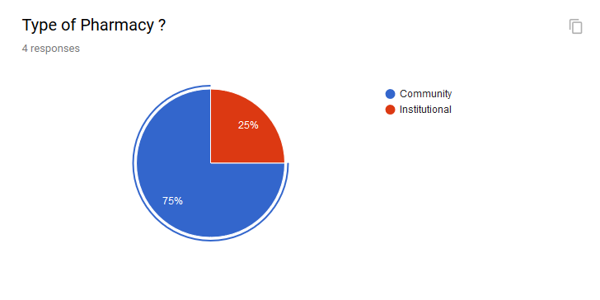

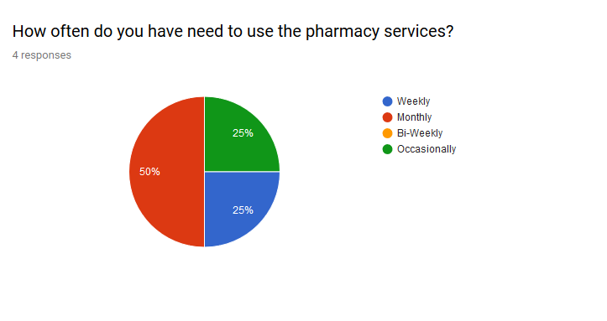

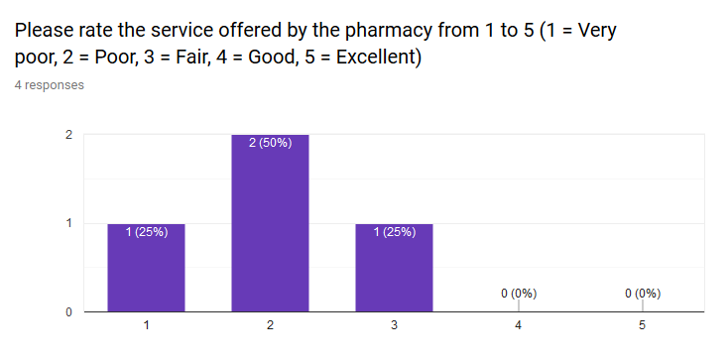

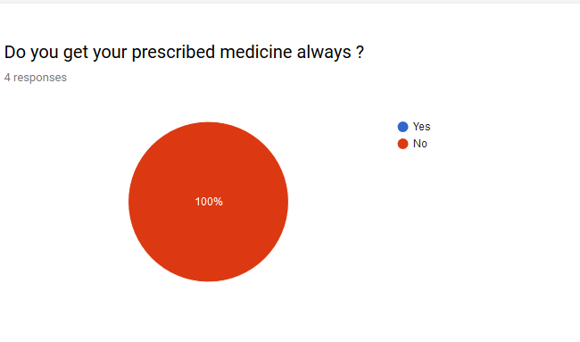

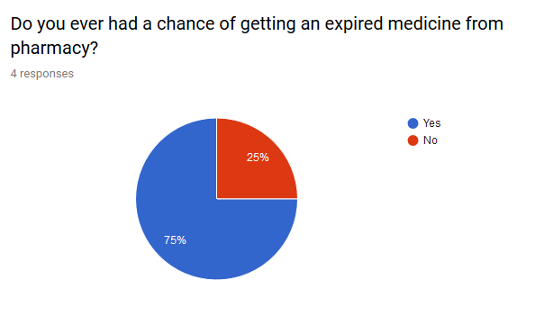

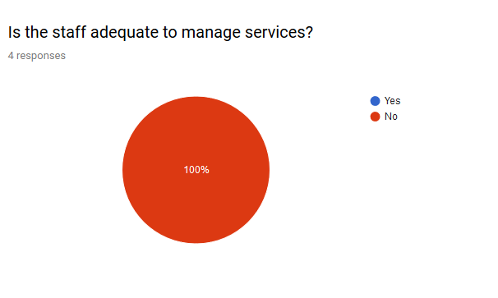

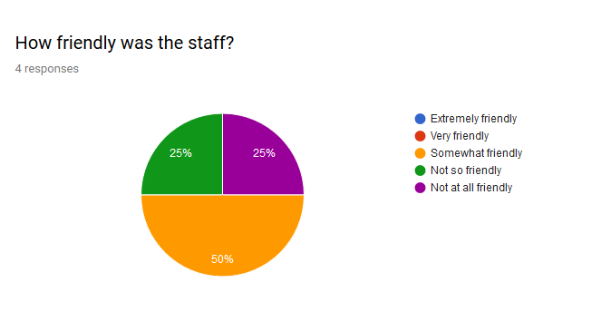

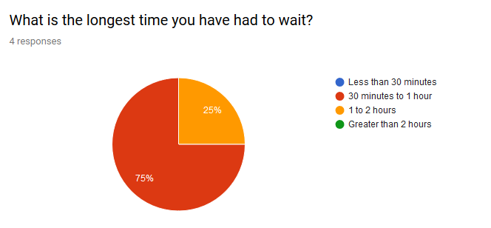

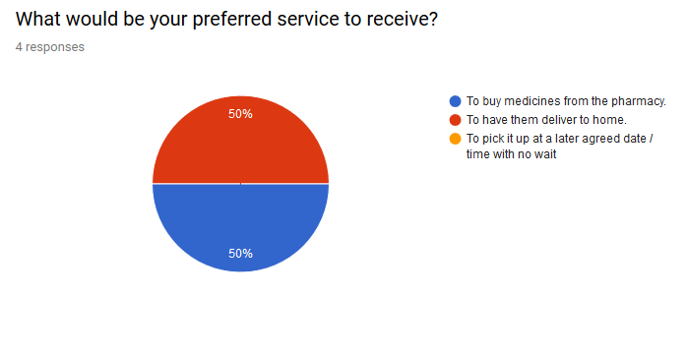

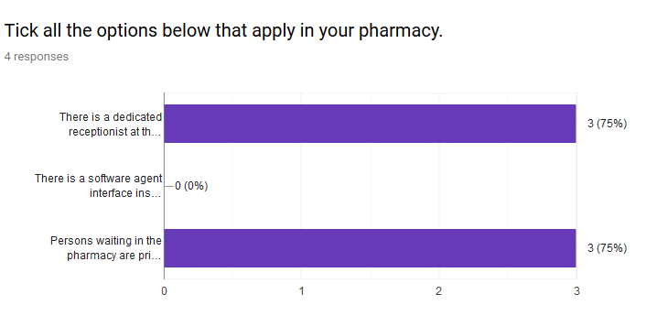

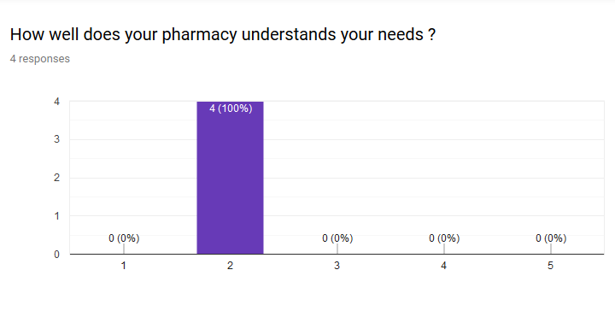

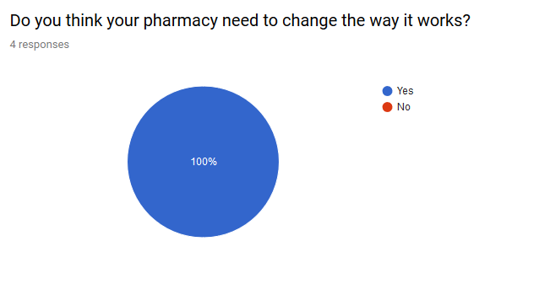

After analyzing the statistics, we deduced from the data that the pharmacies need to change the way they are working. The problems that arise are majorly from the manual organization of work. Moreover, they need to make their customer satisfaction a priority.

Either increase the staff or implement such systems that have fast response time.

Feedback from Pharmacy Owners:

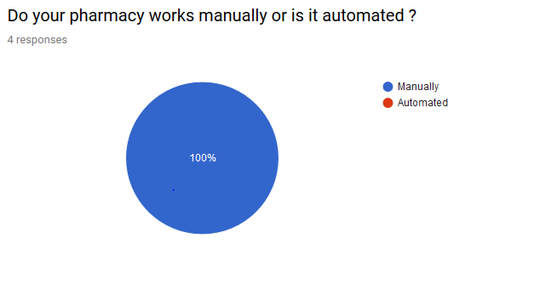

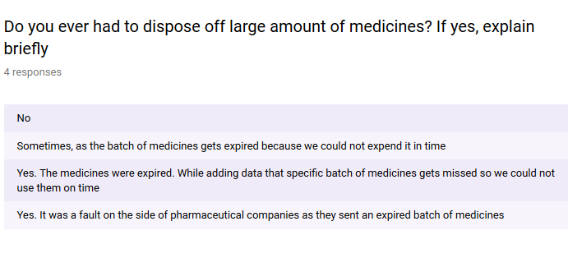

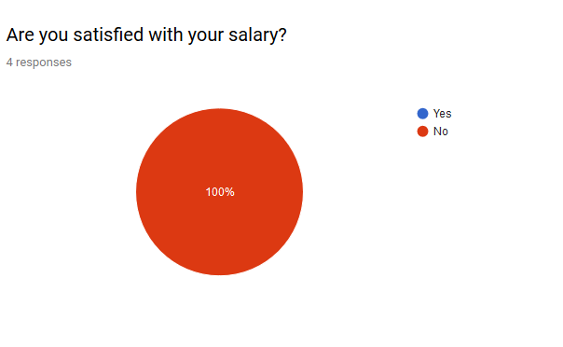

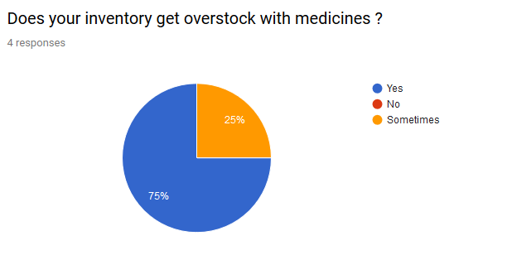

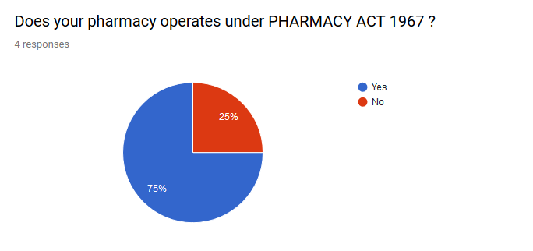

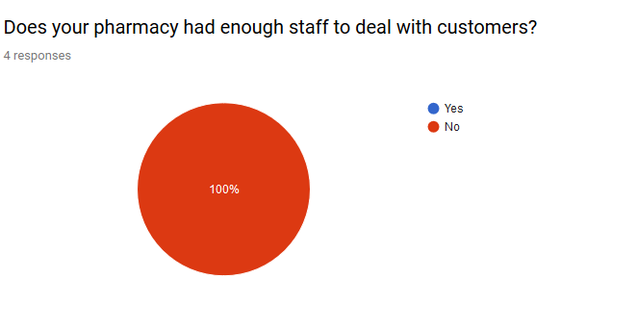

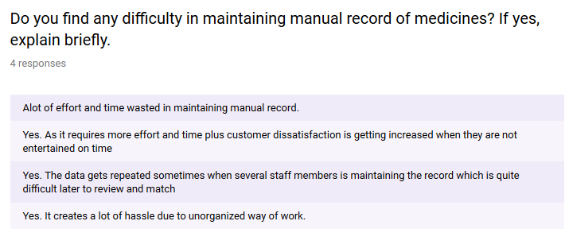



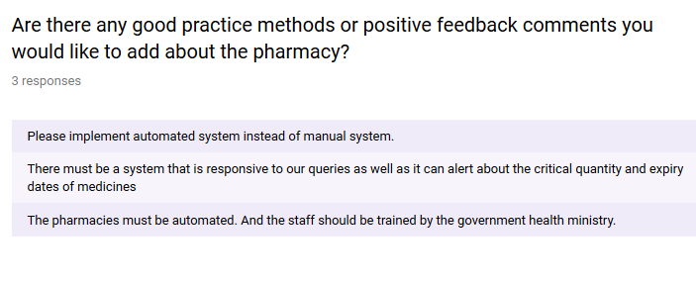After analyzing we came to know that almost 100% pharmacies are manual. And 75% of them are licensed under Pharmacy ACT 1967 that means that need to follow standardized process in order to retain their license.

# **Business Process Modelling Notation (BPMN)**